Cidana PlayerControl SDK Quick Start

What's in SDK release package?
Cidana PlayerControl SDK includes a whole set of pre-built executable applications and libraries, very detailed sample code of the demo player and documents for reference.

Following is the list of modules of release package:
.\SDK\setup.exe | installation package of sample code
.\Docs\CiplSimpleAPI\CiplSimpleAPI_Manual.chm | API manual for CiplSimple interface
.\Bin\*.* | executable applications and libraries
.\Plat\STANDARD_CE6_SDK.msi | standard CE6.0 SDK
.\Plat\STANDARD_SDK.msi | standard CE5.0 SDK (optional)

Environment Setup for Development

Windows XP/7 32bit/64bit

Visual Studio 2005
Visual Studio 2005 Professional (ENU) is chosen by it can support Window CE 5.0/6.0 well.
Following patches should and only be updated:
1. VS80sp1-KB926601-X86-ENU.exe
2. VS80sp1-KB932232-X86-ENU.exe
3. VS80sp1-KB949009-X86-INTL.exe

Windows SDK
The version of Windows SDK we choose is version 6.1 for Windows 2008 with .NET framework 3.5, only develop PC version is required to install this SDK
Configurations in Visual Studio 2005:
Add following paths and set them to top of order in VC include directories:
C:\Program Files\Microsoft SDKs\Windows\v6.1\Include
C:\Program Files\Microsoft SDKs\Windows\v6.1\Samples\Multimedia\DirectShow\BaseClasses
Add following path in VC lib directories:
C:\Program Files\Microsoft SDKs\Windows\v6.1\Lib

Windows CE SDKs
To develop on Windows CE platform, the following Windows CE SDKs are required to install:
Windows CE 5.0 Standard SDK
Windows CE 6.0 Standard SDK

Installation of sample code package

Please follow the steps to install the sample code in your computer:
1) If user have installed previous version of Cidana PlayerControl SDK, please uninstall it first before updating.
2) Double click "setup.exe" to launch installation:
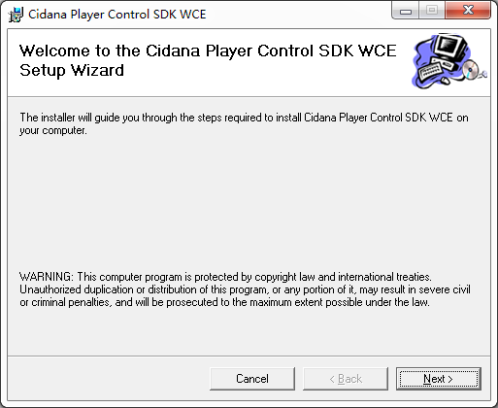
3) "Next" to enter a configuration page, user can change the installation path to any disk with available space.
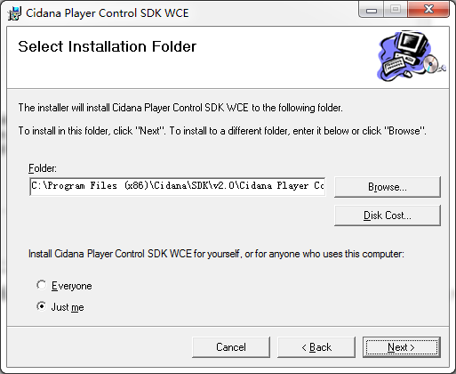
3) Easy "Next" to "Next" steps can finish the installation in a few minutes.

How to develop on PC?
Before starting develop, please make sure all environments are setup in Environment Setup for Development
The entrance for the sample code is at the installation folder, for example: C:\Program Files (x86)\Cidana\SDK\v2.0\Cidana Player Control SDK WCE\Samples\CiplSample.sln
Select target platform as following in red circle and all sample code can be built to executable application
